UNIT I
EAR

DEVELOPMENT AND ANATOMY
OF THE EAR
DEVELOPMENT OF THE EAR

Auricle:
Develops from a series of six tubercles that form around the first brancheal cleft

External auditory canal:
Develops from the ectoderm of the first brancheal cleft.

Tympanic membrane:
The outer epithelial layer: Develops from the ectoderm of the first brancheal cleft.
The middle fibrous layer: from the mesoderm between the first brancheal cleft and the tubotympanic recess
The inner mucosal layer: develops from the endoderm of part of the tubotympanic recess.

Eustachian tube and tympanic cavity:
Developed from the tubotympanic recess.

Malleus and Incus:
Developed from the mesoderm of the first brancheal arch.

The stapes:
The head, neck and crura from the mesoderm of the second brancheal arch, the mesoderm from the otic capsule.

Inner ear:
Developed from the otic capsule.

Development of the inner ear begins early during embryogenesis. By the end of the eighth week, the membranous labyrinth has assumed its characteristic convoluted shape. Gradual ossification of the otic capsule develops around the membranous labyrinth and is essentially complete by birth. Maturation of the sensory epithelium occurs long after formation of the membranous labyrinth, during the late second and early third trimester. By the twenty-sixth to twenty-eighth week of gestation, hair cell and auditory neural development are largely complete. Thus, the normal human fetus may be able to hear 2.5 to 3 months before birth.

The mastoid process:
The mastoid portion of the temporal bone if flat at birth and the stylomastoid process lies immediately behind the tympanic ring. As the air cells develop and with the pull of the sternomastoid muscle the mastoid process grows downwards and forwards and the stylomastoid foramen comes to lie in undersurface of tympanic bone.
Pearls in bullets
- Auricle Develops from a series of six tubercles
- Tympanic membrane develops from the first brancheal cleft
- Eustachian tube and tympanic cavity developes from the tubotympanic recess
- The malleus and incus developes from the mesoderm of the first brancheal arch.
- The stapes develops from from the mesoderm of the second brancheal arch (head, neck and crura), and the otic capsule (footplate).
- The inner ear developes from the otic capsule

References
- Anson JA, Davies J, Duckert LG. Embryology. In: Paparella MM, Shumrick DA, editors. Otolaryngology.Vol 1. Philadelphia (PA): WB Saunders; 1991. p. 3–22.
- Sulik KK. Embryology of the ear. In: Gorlin RJ, Toriello HV, Cohen MM, editors.Hereditary hearing loss and its syndromes. New York: Oxford University Press; 1995. p. 22–42.
ANATOMY OF THE EAR

The ear is divided into three parts
Outer (external) ear
Middle ear
Inner ear
- Auricle
- External auditory canal
- Tympanic membrane
- Tympanic cavity
- Ossicles

- Cochlea
- Vestibule
- Semicircular canals

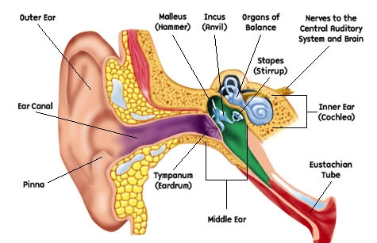

The external ear
The auricle (Pinna)
- Fibroelastic cartilage except the lower part (the lobule). The covering skin is tightly attached to the underlying perichondrium.
- The lateral surface has a series of ridges and depressions

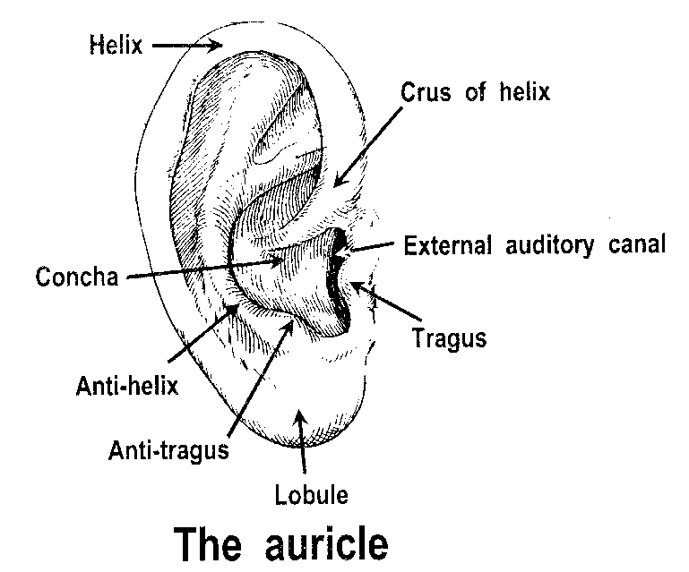

The area between the anterior end of the helix and the tragus is devoid of cartilage. It is continuous with deficiency in the external auditory canal superiorly. Incision through this site will not go through the cartilage. This incision is termed “end aural incision”.

The external auditory canal
Composed of two parts:
Cartilaginous part (8mm); the outer 1/3, has adherent lining skin that contains hair, sebaceous and modified sweet glands (ceruminous glands). Fissures of Santorini is present in this part through which infection may extend from the external ear to the parotid region. It forms incomplete cylinder deficient antrosuperiorly continuous with the area deficient in cartilage between the tragus and helix. The direction of the cartilaginous part is upwards, backwards and laterally
Bony part (16mm); the medial 2/3, the lining skin is thin and doesn't contain hair or ceruminous glands. The lining skin is tightly attached to the underlying periosteum. The narrowest sit of the external auditory canal is the junction between the bony and the cartilaginous parts “isthmus”. The direction of the bony part is downwards forwards and medially. So, the bony and cartilaginous parts are not in line. To make them in line in adults you have to pull the auricle “and the cartilaginous part” upwards and backwards.

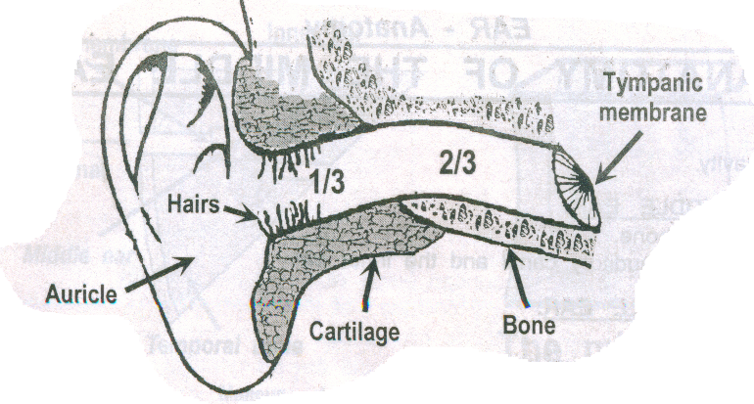

The Tympanic Membrane
Consists of three layers in it lower part ( pars tensa):
- Outer epithelial layer
- Middle fibrous layer
- Inner mucosal layer
The upper part (pars flaccida) has two layers (lacks the middle fibrous layer).
The drum direction is oblique so that the anterior and inferior walls of the external auditory canal are longer than the roof and the posterior walls. The drum is concave inwards.
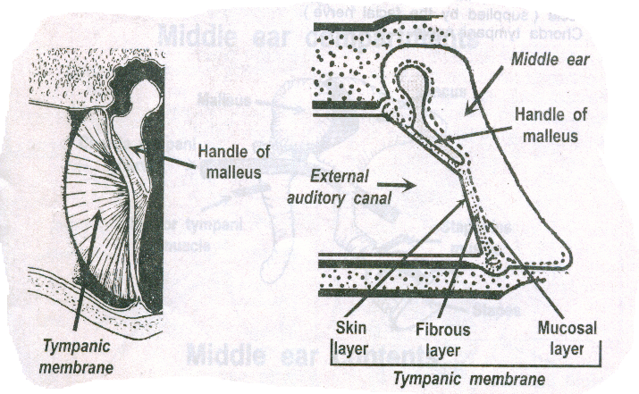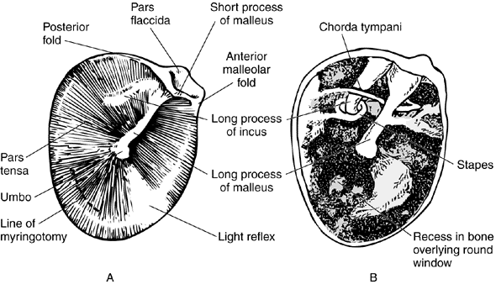

The handle of the malleus lies in the middle fibrous layer with two ligaments extending anteriorly and posteriorly (ant. and post. malleolar ligaments) dividing the drum into two parts; pars tensa inferiorly (3 layers) and pars flaccida or Shrapnel’s membrane superiorly (2 layers).The cone of light lies antroinferiorly (reflection of the examiners light).
An annulus fibrosus
Lpi long process of incus - sometimes visible through a healthy translucent drum
Um umbo - the end of the malleus handle and the centre of the drum
Lr light reflex - antero-inferioirly
Lp Lateral process of the malleus
At Attic also known as pars flaccida
Hm handle of the malleus

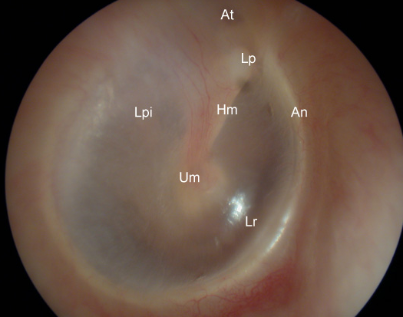
The middle ear
The middle ear cleft is composed of the tympanic cavity, the Eustachian tube and the mastoid air cell system.
- The middle ear cavity
The middle ear cavity is a narrow air-filled cavity located in the temporal bones of the skull. It is separated from the external auditory meatus of the outer ear by the tympanic membrane. It is separated from the inner ear by a bony partition which contains two windows; the oval window ( fenestra vestibuli) and the round window ( fenestra cochlea).

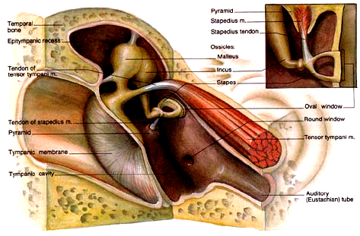

The tympanic cavity is divided into the epitympanic, mesotympanic, and hypotympanic regions. The hypotympanic portion is that portion of the middle ear that lies inferior to the aperture of the eustachian tube and the round window niche (RWN). The mesotympanic portion of the middle ear is limited superiorly by the horizontal portion of the facial canal and inferiorly by the RWN. The epitympanum is the portion of the middle ear that is limited superiorly by the bony roof of the middle ear called the tegmen tympani and inferiorly by the lateral attic wall (scutum).

Walls of the middle ear:
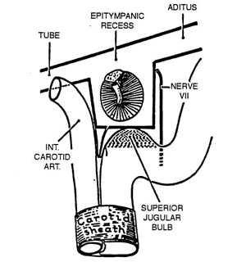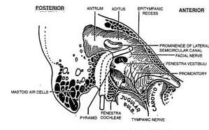
Lateral wall:
The tympanic membrane and the lateral attic wall.
The medial wall:
Shows the following features
- The promontory; produced by the first turn of the cochlea.
- The horizontal part of facial nerve in its bony canal (tympanic part)
- Two openings
      - The oval window; above and behind the promontory; closed in life by the footplate of stapes.
      - The round window; below and behind the promontory; closed in life by the secondary tympanic membrane.

Superior wall:
The tegmen tympani separating the middle ear cavity from the middle cranial fossa.
Inferior wall:
Thin bony plate separating the middle ear cavity from the jugular bulb.
Anterior wall:
The internal carotid artery, the Eustachian tube opening and the canal for the tensor tympani muscle.
Posterior wall:
The aditus ad antrum (connecting the mastoid antrum with the tympanic cavity), the stapedius muscle and the vertical part (mastoid segment) of facial nerve in it bony canal.
Contents of the middle ear:
Filled with air coming through the Eustachian tube.
Three small bones: malleus (the lateral most of the three ossicles. Its handle is embedded in the tympanic membrane and its head is located in the attic region to articulate with incus. Incus which is the middle ossicle. It articulates with the stapes head forming the incudostapedial joint (the least part for blood supply of the ossicles). Stapes with its footplate closing the oval window.
Two muscles: stapedius and tensor tympani muscles. They function to protect the inner ear from the harmful effect of very loud sound. The stapedius muscle is supplied by the facial nerve while the tensor tympani muscle is supplied by the mandibular division of trigeminal nerve.
One nerve: chorda tympani nerve (branch of the facial nerve). It passes between the malleus and incus. It supplies the anterior 2/3 of the tongue with taste and secretomotor to the submandibular and sublingual salivary gland.
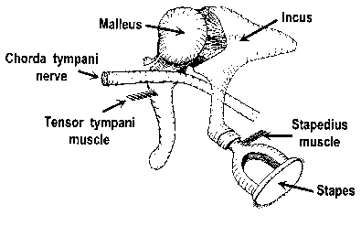
- The Eustachian tube
Its function is to equalize the pressure on both sides of the tympanic membrane. It Connects the middle ear with the nasopharynx. Its length: 36mm. its lateral 1/3 (12mm) is bony and the medial 2/3 (24mm) is cartilaginous. In children it is shorter, wider and more horizontal than in adults. It is closed at rest but opens actively (by the tensor palate muscle) during swallowing, yawning and Valsalva maneuver.
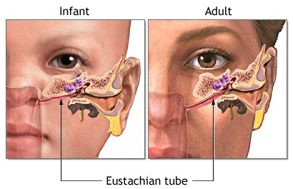
- The mastoid air cell system
  - Lie within the mastoid process
  - The mastoid air cells are air filled spaces that communicate with each other. The first and the largest of them is called the mastoid antrum. The mastoid antrum communicates with the middle ear cavity through and opening called aditus ad antrum.
  - The number and size of the cells vary, so the mastoid process may be classified into three main types
    - Peumatic mastoid: with high cellularity (the commonest, 80%).
    - Sclerotic mastoid: very minimal cellularity with only the mastoid antum.
    - Diploic mastoid: has few air cells with bone marrow inside.
- The air cells are arranged in groups according to their anatomical site e.g. apical cell in petrous apex.

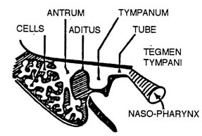
Nerve supply of the ear
The auricle:
Anterior (lateral) surface
- Upper 2/3 by the auriculotemporal branch of mandibular division of trigeminal n.
- Lower 1/3 by the greater auricular nerve from the cervical plexus (C2,3).
Posterior (medial) surface
- Lower 2/3 by the greater auricular nerve from the cervical plexus (C2,3).
- Upper 1/3 by the lesser occipital nerve from the cervical plexus (C2,3).
The external auditory canal and tympanic membrane
- Anterior ½ by the auriculotemporal nerve of trigeminal nerve.
- Posterior ½ by the auricular branch of vagus (Arnold nerve).

The tympanic cavity
- Tympanic branch of glossopharyngeal nerve (nerve of Jackobson)

The inner ear

The petrous portion of the temporal bone houses the labyrinth with its attendant sensory structures responsible for auditory and balance function. Within the bony labyrinth is contained the membranous labyrinth, which represents a continuous series of epithelial lined tubes and spaces of the inner ear containing endolymph and the sense organs of hearing and balance. The membranous labyrinth can be divided into three regions that are interconnected: the pars superior or the vestibular labyrinth including the semicircular canals and the utricle, the pars inferior (cochlea and the saccule), and the endolymphatic duct and sac. All of the sense organs of the labyrinth have in common that they contain hair cells with rigid cilia and are innervated by afferent and efferent neurons. Displacement of the cilia of the hair cells is responsible for opening potassium and calcium channels that initiate the electrical potential within the hair cell that is then leaked into the afferent neuron and carried to the brainstem.

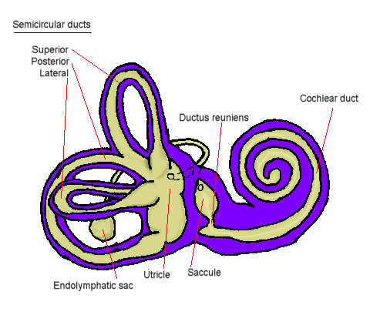
- Cochlea: The cochlear duct, the auditory portion of the labyrinth, extends approximately 35 mm. The cochlear duct and associated sensory and supportive structures assume the form of a spiral similar to a snail shell 2 3⁄4 turns.
- Semicircular canals (lateral, superior and posterior): Each canal forms 2/3 of a circle turns. They are perpendicular to each other.
- The vestibule: between the cochlea and semicircular canal. The boy vestibule houses the saccule and the utricle.

The sensory end-organs of the inner ear
- In the cochlea: the organ of Corti fig. 10
- In the semicircular canal: called the crista fig. 11
- In the utricle and saccule: called the macula fig. 12

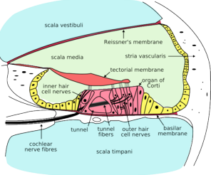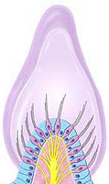
Organ of Corti The crista

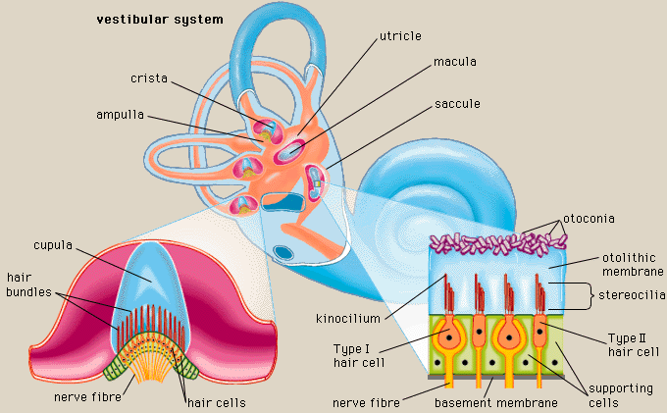
The macula

